- We expect the Monetary Policy Committee to hold Bank Rate at 4% at next week's meeting. Most MPC members are more concerned about the implications of cutting rates too quickly than too slowly, and will want to see evidence of sustained downside surprises in the data and that pay growth will slow to a target-consistent pace next year before voting to cut again.
- Changes to the Monetary Policy Statement will be key to the MPC's communications in the coming months. The new format will attempt to better describe the centre of gravity on the committee and give individual members space to explain their decisions and outlook.
- Those towards the centre of the MPC might be non-committal on the timing and pace of future rate cuts until they've seen the contents of the Budget on November 26, the two labour market and inflation releases published ahead of December's meeting, and more clarity on the size of next year's pay settlements.
The Bank of England's Monetary Policy Committee has been following a 'cut-hold' tempo since it kicked off its rate-cutting cycle in August 2024. But though the MPC cut again in August, there was a clear change of messaging in the minutes of that meeting and at the September meeting, making clear that the majority were more concerned about the prospect of inflation remaining high. In our view, this change of emphasis made a November hold likely, unless there were major downside surprises in the inflation data.
The MPC's worries were two-fold. First, the lack of passthrough from slowing pay growth to services inflation. And second, that high inflation in salient categories, such as food, risks keeping inflation expectations elevated or even pushing them up further.
On balance, data published since the September meeting should help to slightly ease some of the MPC's worries about above-target inflation persisting. Though there are caveats behind some of the softer outturns, it has broadly come in a bit weaker than forecast by BoE staff in August's Monetary Policy Report. But it's unlikely to be enough to convince a majority to back a November rate cut.
Chart 1: Recent services inflation and pay growth outturns have slightly undershot BoE staff projections
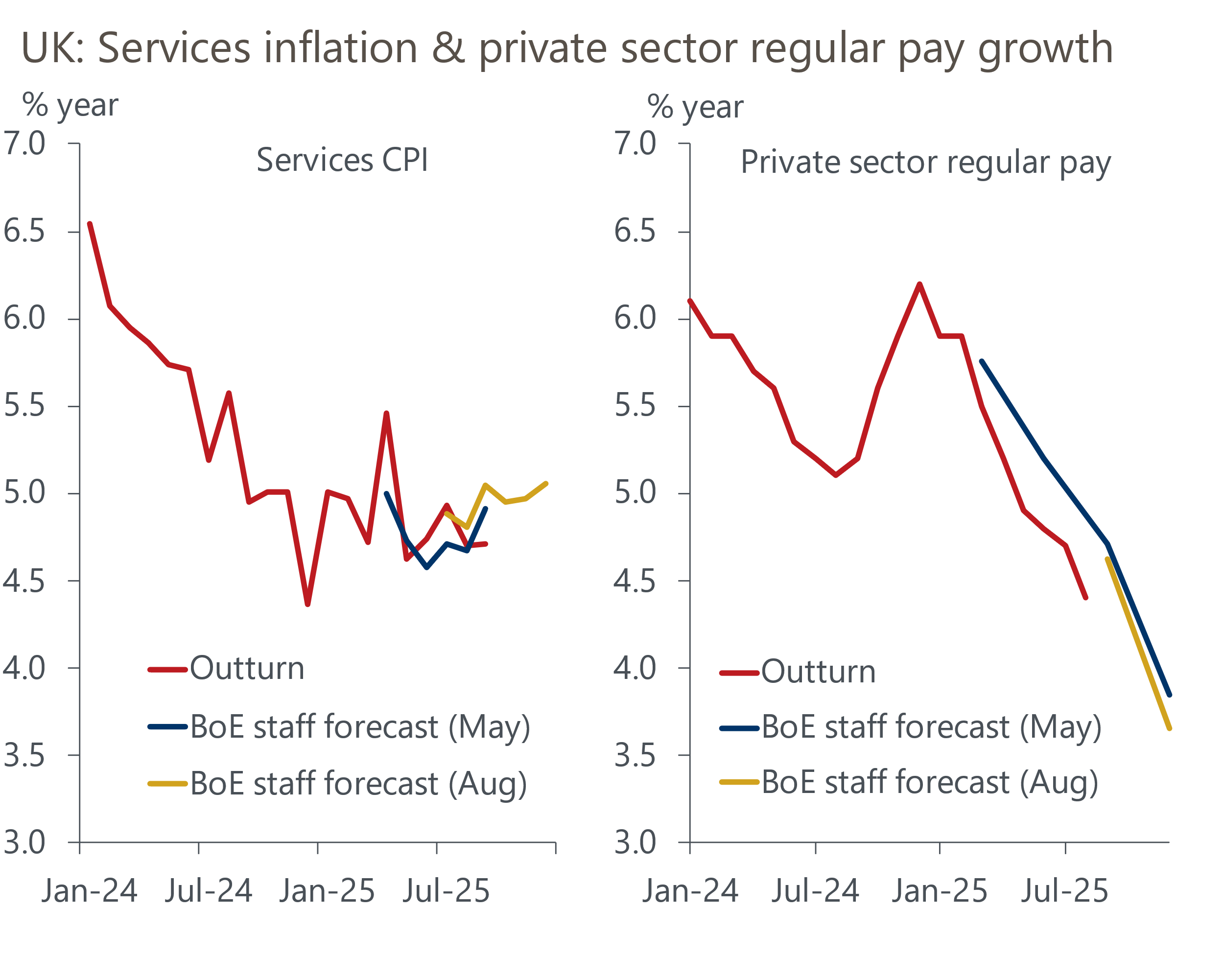
Sources: Haver Analytics, Bank of England Monetary Policy Report

September's CPI inflation reading was unchanged at 3.8%, 0.2ppts below the BoE's forecast. The undershoot was largely down to two factors. First, services inflation remained at 4.7%, 0.3ppts below the BoE's projection (Chart 1). This was due to a mixture of temporary movements in volatile sub-categories – including air fares and live music – and a genuine cooling in the MPC's favoured measure of underlying services inflation, which excludes indexed prices and some of the more volatile components. Second, there was an unusually weak outturn for food prices in September that left inflation in that category running 0.5ppts below the BoE's forecast. However, the Office for National Statistics suggested this was partly the result of greater discounting and sales efforts, which are unlikely to be sustained.
It appears we're now likely to avoid a 4% reading for CPI, a rate that BoE research found could trigger higher inflation expectations. And with some tentative evidence that cooling pay growth might finally be passing through into inflation, the bar to additional rate cuts looks a little lower. But the MPC is unlikely to draw any firm conclusions on one month's worth of data, and will want to see more sustained evidence that underlying inflationary pressures are softening before cutting again.
Private sector regular pay growth – the MPC's preferred measure of pay growth – has been slightly weaker than the MPC expected in recent months, but still remains around 1ppt above a pace that would be consistent with sustainably meeting the committee's 2% inflation target in the medium term.
The MPC's view on the evolution of pay growth beyond the near term will be driven by how next year's pay settlements and labour market conditions are developing more broadly. The BoE's Decision Maker Panel for September reported that past and future pay growth appear to have stabilised at a relatively high level (Chart 2). Meanwhile, the BoE's Agents report that pay deals are likely to be in the 2%-4% range, but they will be doing a full survey of firms over the next couple of months. Elsewhere, measures of hiring intentions remain soft, but HMRC's latest count of employees on payrolls suggested that job losses are starting to bottom out, providing tentative evidence that the drag from April's employee national insurance contributions increase is beginning to fade.
Chart 2: Wage pressures appear to have stabilised at an elevated level
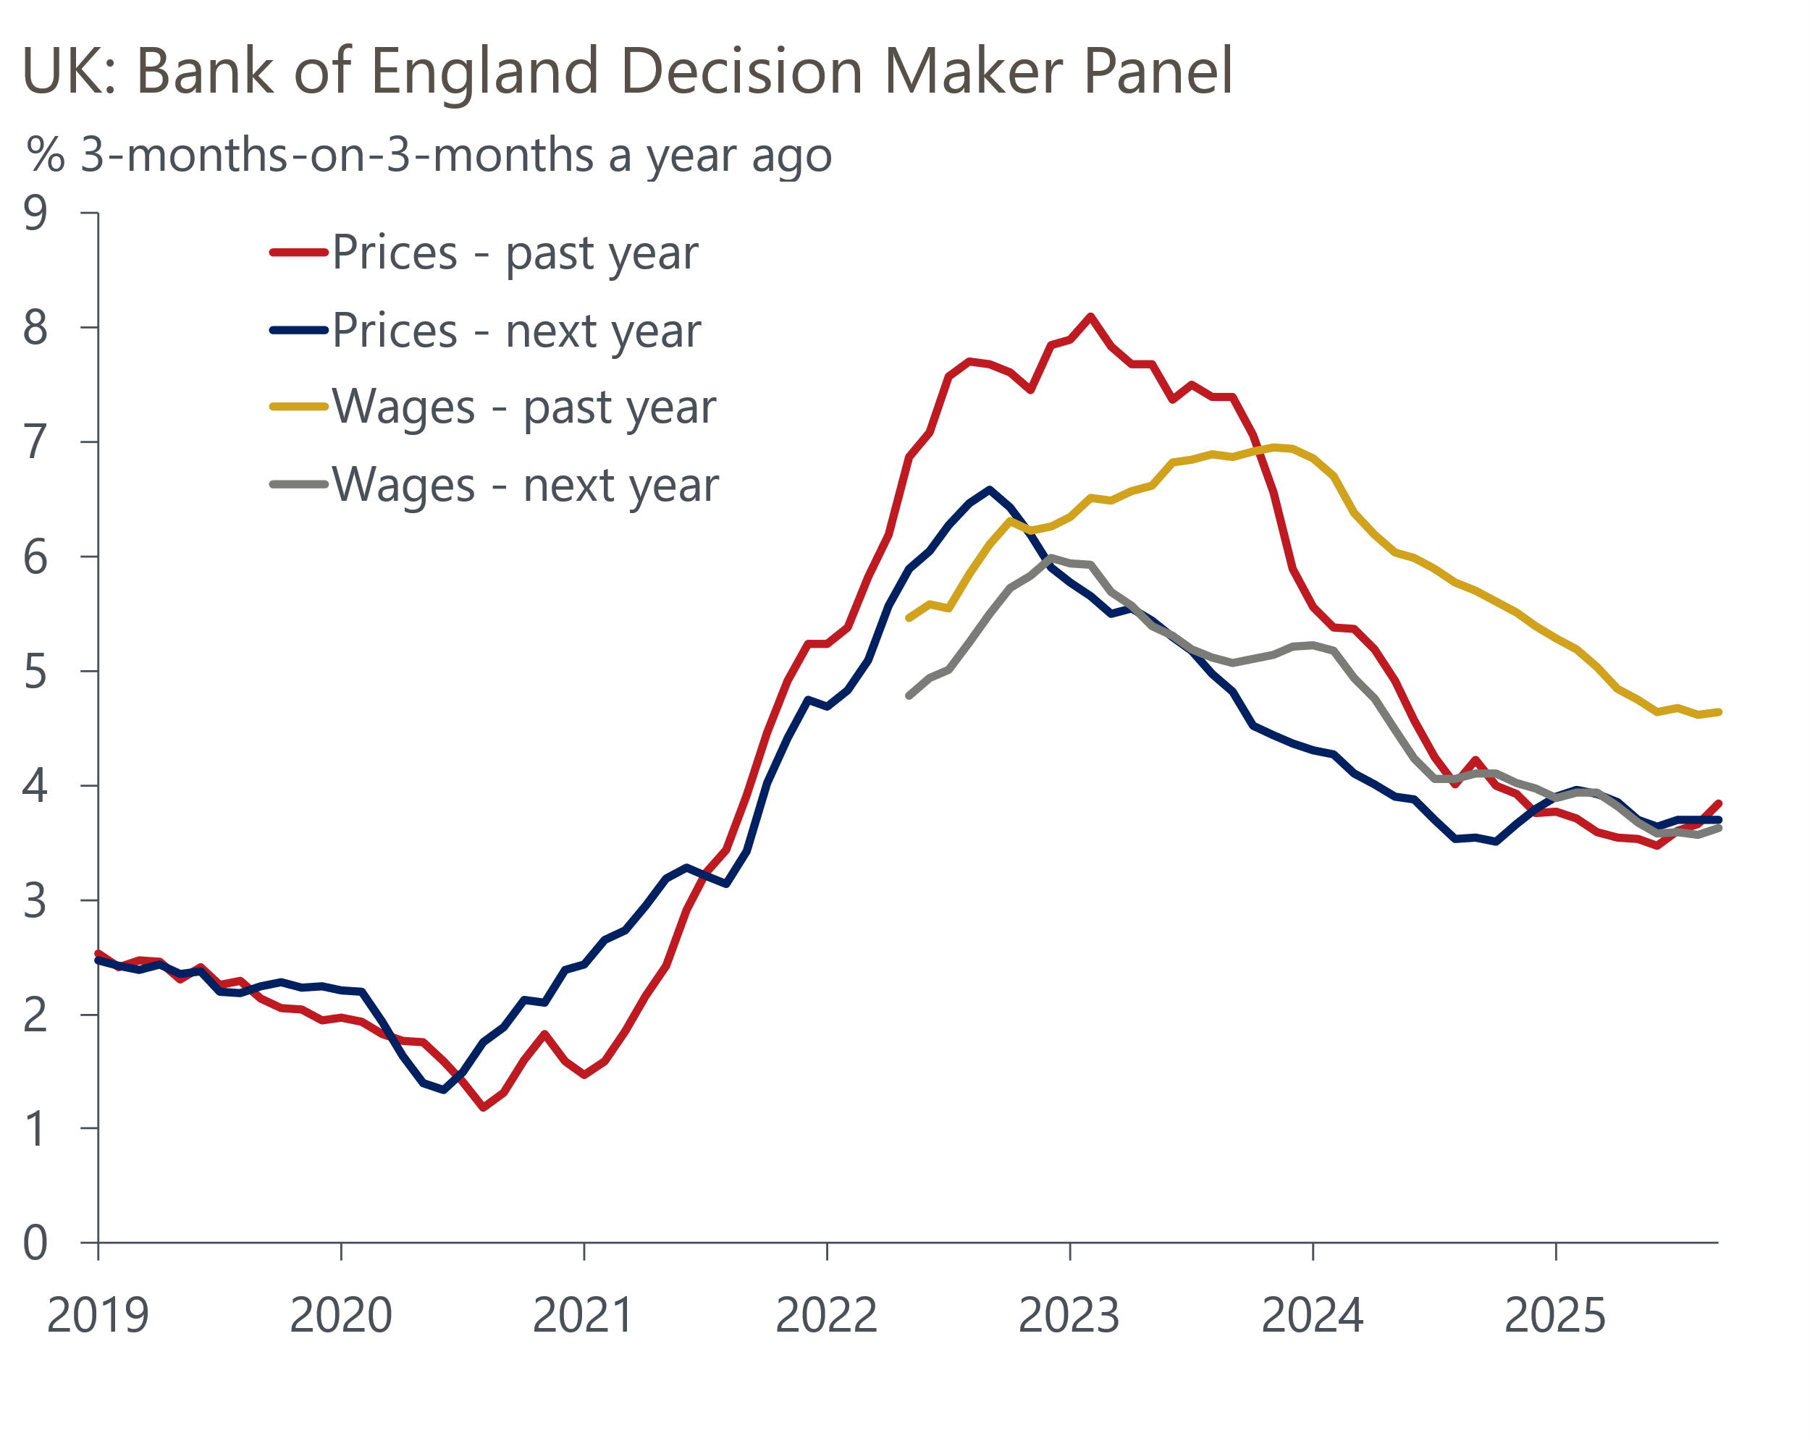
Source: Haver Analytics

More dovish market pricing won't be fully captured in the MPC's forecast
An added complication is that the November meeting follows material movements in financial market pricing. After the September meeting, markets saw just a 27% chance of a further 25bp rate cut by the end of this year. But in reaction to September's soft CPI inflation reading and favourable inflation news from abroad, the market-implied probability of a cut by year-end has risen to 65% at the time of writing.
The MPC will present its updated forecasts at the November meeting. However, with most of the shift in market pricing occurring 11 days through the 15 working-day period used by BoE staff to generate the forecast's conditioning assumptions, November's forecast will be based on market expectations for Bank Rate that are higher over the next year than those used in August (Chart 3).
Chart 3: Despite the recent dovish repricing, November's forecast will be based on a higher market curve
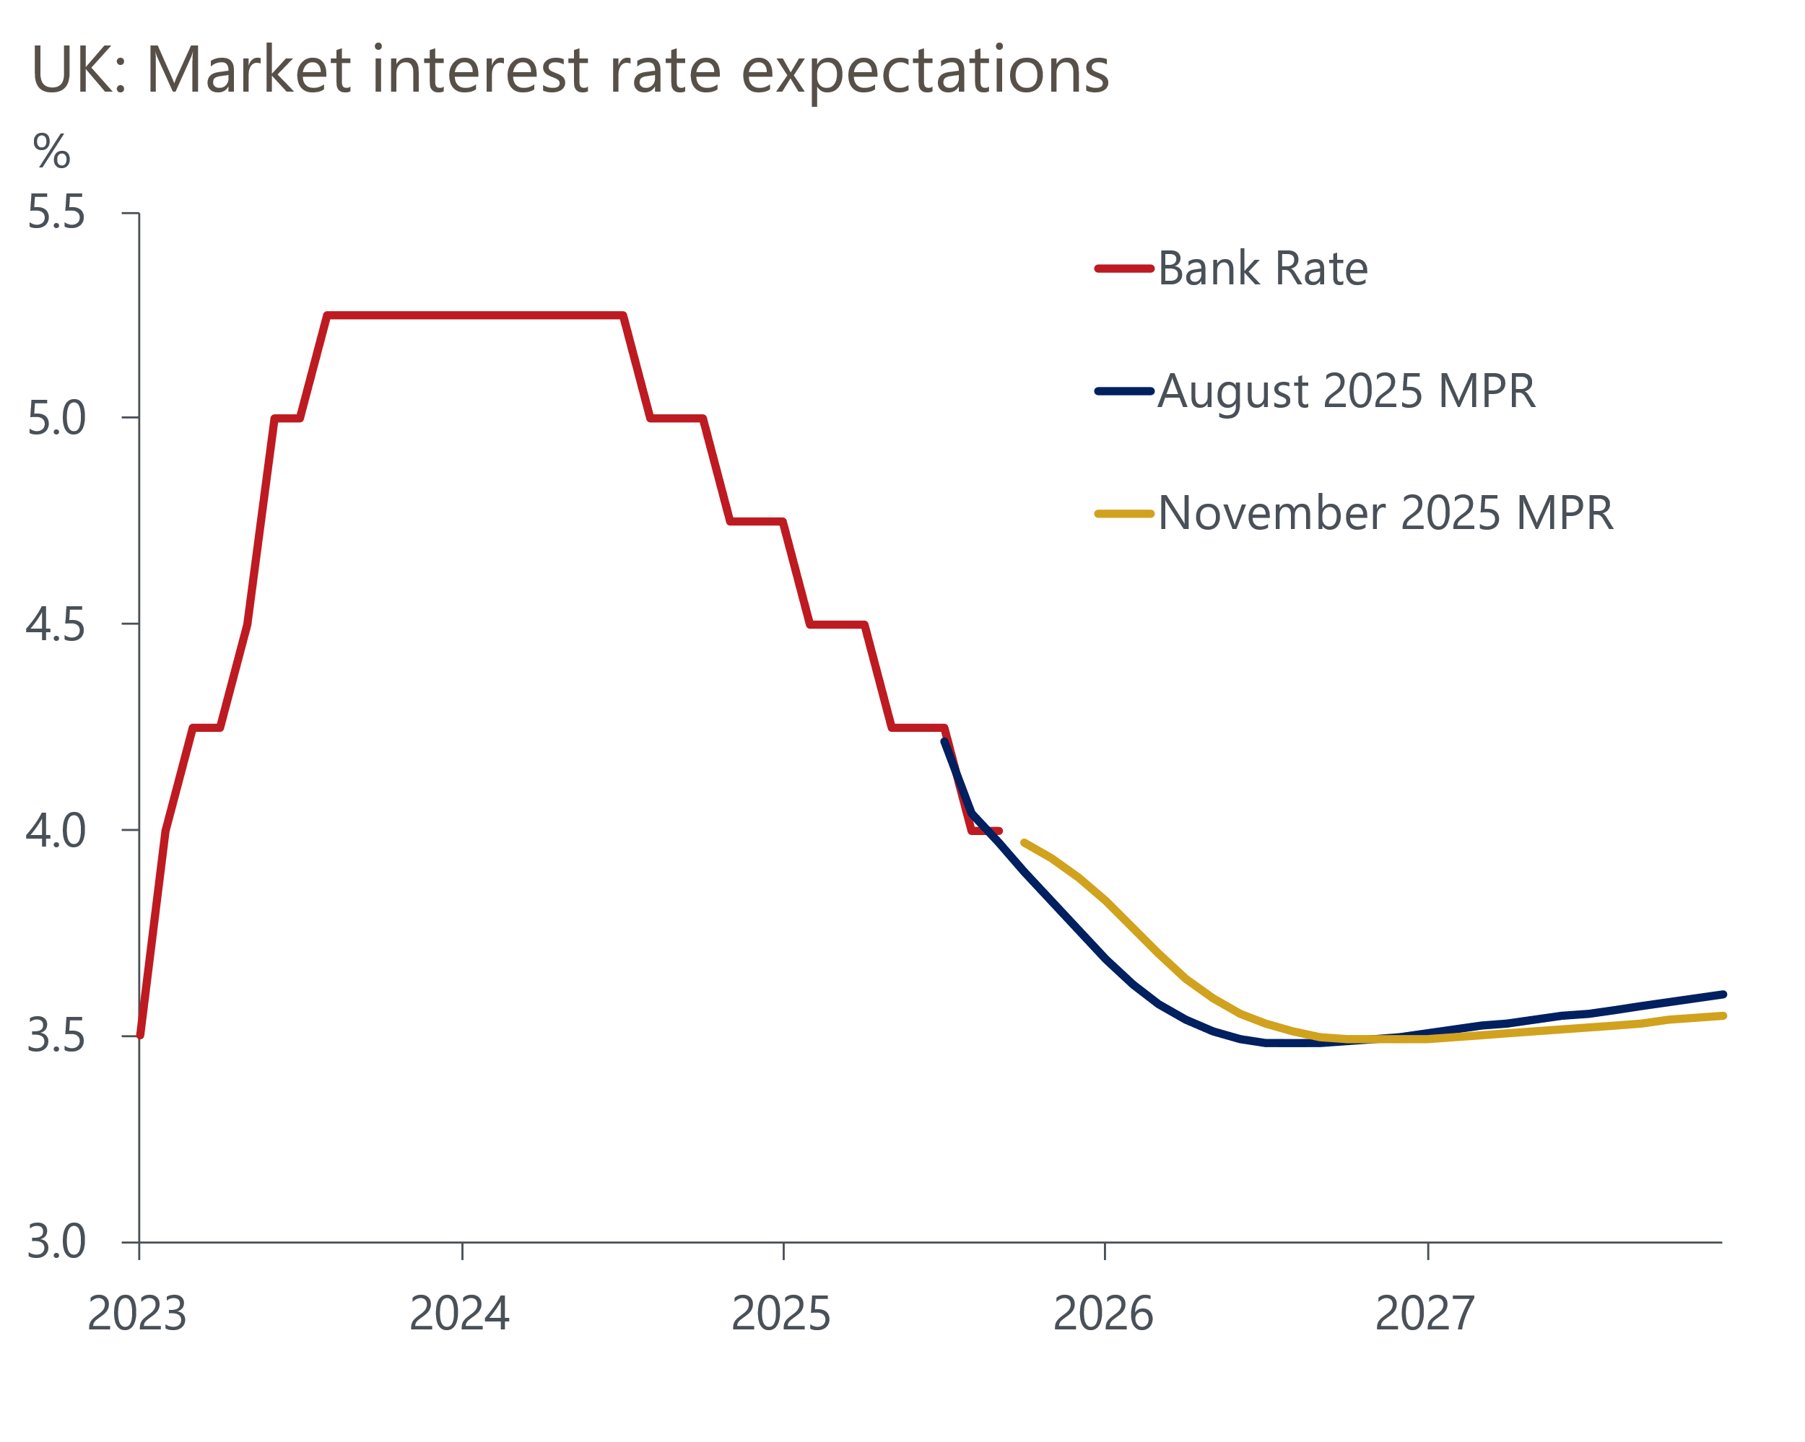
Source: Haver Analytics
Recent favourable outturns mean November's inflation forecast will start from a slightly lower level. With the new forecast conditioned on a higher market curve for Bank Rate and weaker European gas and electricity futures prices, this should put some downward pressure on the forecast over the next couple of years. However, the MPC has been deprioritising its forecast in recent months and will probably not provide a good steer on the likely path of Bank Rate.

Changes to the Monetary Policy Statement will be crucial
More key to the MPC's communications will be changes made to the Monetary Policy Statement. From November, the policy statement will be much shorter and attempt to better describe the centre of gravity on the committee, while downgrading the importance of the MPC's central forecast to the its decision. The MPS will also provide individual members with space to explain the reasoning behind their votes, the balance of risks, and their own sense of the economic outlook. With the MPC so divided, the shift towards a more transparent form of communication will be particularly important for assessing what the committee's swing voters are focusing on.

We expect the MPC to hold in November and remain cautious for the time being
As of October 30, market pricing implies a 28% chance of a 25bp cut at the November meeting. We agree that a cut is relatively unlikely. Governor Andrew Bailey has emerged as the committee's 'swing voter' in recent months. Though he has not commented publicly since September's inflation release was published, he struck a relatively balanced tone when speaking at the International Monetary Fund's annual meeting in October and made little attempt to prepare the ground for a November cut (Table 1 shows our analysis of recent comments by MPC members).
We don't think recent data has been weak enough to swing the Governor in favour of a November cut. But there's a decent chance that November's vote to keep Bank Rate unchanged at 4% will be tighter than September's 7-2 decision, with Dave Ramsden the most likely member to join Swati Dhingra and Alan Taylor in voting for a cut.
The MPC has been clear that it still expects to cut Bank Rate further, but uncertainty around the timing and pace of those cuts lingers. The upcoming Budget on November 26 could be a key influence, particularly if – as we expect – the Chancellor announces a sizeable tightening of policy. The MPC will also see two further labour market and inflation releases before the December meeting, so that meeting will certainly be live. We think a majority of committee members will want to see much clearer evidence of downside surprises in the data being sustained, and the Agents' findings on next year's pay deals before voting to cut Bank Rate again.
Table 1: Key comments by MPC members
Speaker and link | Date | Key takeaway
Pill | October 17 | Pill maintained his hawkish outlook, saying that there was a need to recognise that the stubbornness of inflationary pressures is becoming more pressing. Therefore, he argued that it will continue to be "important to guard against the risk of cutting rates either too far or too fast".
Taylor | October 14 | Taylor argued an increasingly likely scenario is one in which inflation undershoots and sinks below the 2% target in 2026, and the economy moves into a weakened state for a sustained period with output and employment below potential. As a result, Bank Rate needed to be on a lower path.
Bailey | October 14 | The Governor struck a relatively balanced tone when speaking at the IMF. Bailey highlighted the competing threats from a softening labour market and above-target inflation. He offered no pushback against financial market pricing, which at the time saw a 9% chance of a 25bp cut in November.
Mann | October 9 | Mann reiterated existing concerns that policy restrictiveness should be maintained to mitigate the upside risks to inflation from higher inflation expectations. She also argued that restrictive policy could be justified on the grounds that high and volatile inflation has had a scarring effect on consumer spending and growth by prompting more precautionary saving.
Breeden | September 30 | Breeden argued that the recent resurgence in inflation reflected external shocks and was likely to unwind. But she was also mindful of the risks presented by current high rates of inflation and implied that she wasn't strongly minded to vote for a rate cut in November at the time.
Ramsden | September 29 | Ramsden maintained that the underlying causes of the recent inflation spike were unlikely to be seen again and that there were positive signs on taming wage pressures. He concluded by saying that the risks for prices are "balanced", but that he "sees scope for further removal of policy restraint".
Dhingra | September 26 | Dhingra reaffirmed her more dovish stance, stating that "we can afford to cut rates further and not put additional strain on economic growth without threatening the inflation target". This was based on her view that UK inflation remaining higher than in major Eurozone countries could largely be explained by administered prices and global commodity shocks.
Greene | September 24 | Greene said that recent shocks had caused structural shifts in the supply-side of the economy and moved the risks to the inflation outlook to the upside. Thus, monetary policy should remain restrictive as a risk management approach to guard against inflation and to try to offset recent supply shocks.
Source: Oxford Economics

